1. "use client";
import React, { useRef } from "react";
import { useScroll, useTransform, motion, MotionValue } from "framer-motion";

export const ContainerScroll = ({
titleComponent,
children,
}: {
titleComponent: string | React.ReactNode;
children: React.ReactNode;
}) => {
const containerRef = useRef<HTMLDivElement>(null);
const { scrollYProgress } = useScroll({
target: containerRef,
});
const [isMobile, setIsMobile] = React.useState(false);

React.useEffect(() => {
const checkMobile = () => {
setIsMobile(window.innerWidth <= 768);
};
checkMobile();
window.addEventListener("resize", checkMobile);
return () => {
window.removeEventListener("resize", checkMobile);
};
}, []);

const scaleDimensions = () => {
return isMobile ? [0.7, 0.9] : [1.05, 1];
};

const rotate = useTransform(scrollYProgress, [0, 1], [20, 0]);
const scale = useTransform(scrollYProgress, [0, 1], scaleDimensions());
const translate = useTransform(scrollYProgress, [0, 1], [0, -100]);

return (
<div
className="h-[60rem] md:h-[80rem] flex items-center justify-center relative p-2 md:p-20"
ref={containerRef}
>
<div
className="py-10 md:py-40 w-full relative"
style={{
perspective: "1000px",
}}
>
<Header translate={translate} titleComponent={titleComponent} />
<Card rotate={rotate} translate={translate} scale={scale}>
{children}
</Card>
</div>
</div>
);
};

export const Header = ({ translate, titleComponent }: any) => {
return (
<motion.div
style={{
translateY: translate,
}}
className="div max-w-5xl mx-auto text-center"
>
{titleComponent}
</motion.div>
);
};

export const Card = ({
rotate,
scale,
children,
}: {
rotate: MotionValue<number>;
scale: MotionValue<number>;
translate: MotionValue<number>;
children: React.ReactNode;
}) => {
return (
<motion.div
style={{
rotateX: rotate,
scale,
boxShadow:
"0 0 #0000004d, 0 9px 20px #0000004a, 0 37px 37px #00000042, 0 84px 50px #00000026, 0 149px 60px #0000000a, 0 233px 65px #00000003",
}}
className="max-w-5xl -mt-12 mx-auto h-[30rem] md:h-[40rem] w-full border-4 border-[#6C6C6C] p-2 md:p-6 bg-[#222222] rounded-[30px] shadow-2xl"
>
<div className=" h-full w-full overflow-hidden rounded-2xl bg-gray-100 dark:bg-zinc-900 md:rounded-2xl md:p-4 ">
{children}
</div>
</motion.div>
);
};
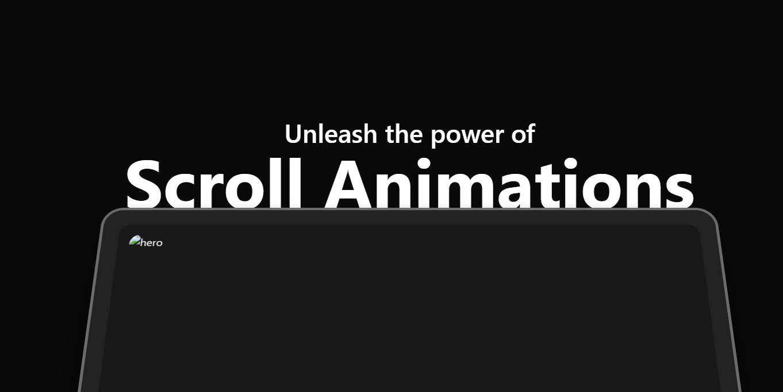

2.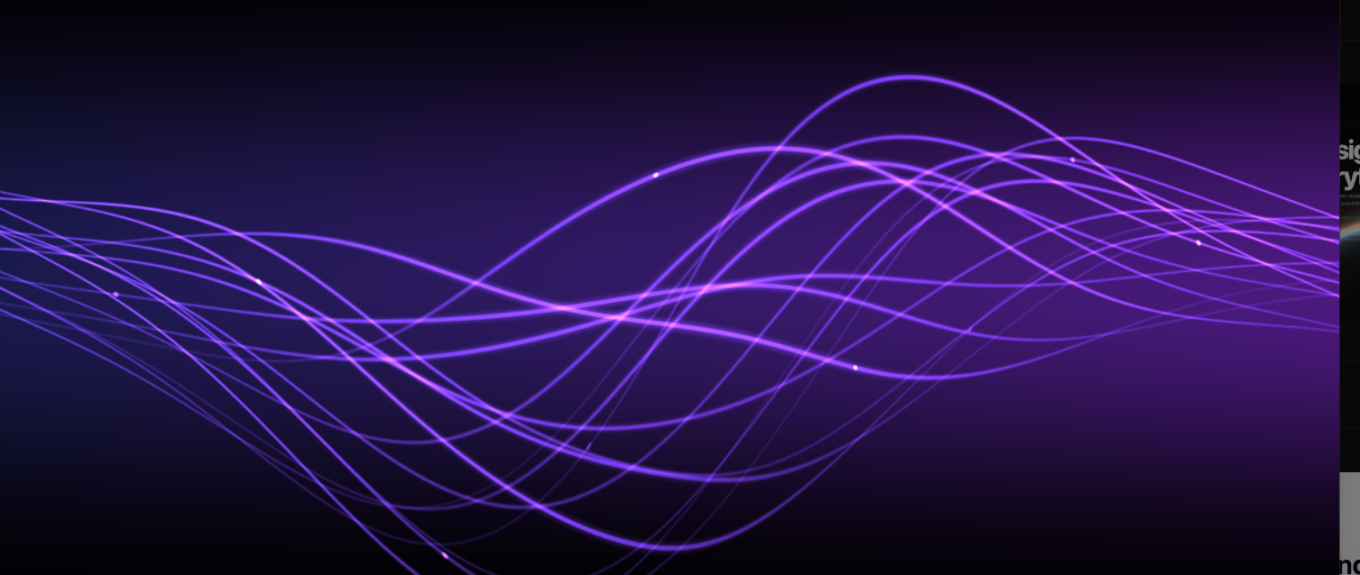
import React, { useEffect, useRef } from 'react';

const ShaderBackground = () => {
const canvasRef = useRef(null);

// Vertex shader source code
const vsSource = `
attribute vec4 aVertexPosition;
void main() {
gl_Position = aVertexPosition;
}
`;

// Fragment shader source code
const fsSource = `
precision highp float;
uniform vec2 iResolution;
uniform float iTime;

const float overallSpeed = 0.2;
const float gridSmoothWidth = 0.015;
const float axisWidth = 0.05;
const float majorLineWidth = 0.025;
const float minorLineWidth = 0.0125;
const float majorLineFrequency = 5.0;
const float minorLineFrequency = 1.0;
const vec4 gridColor = vec4(0.5);
const float scale = 5.0;
const vec4 lineColor = vec4(0.4, 0.2, 0.8, 1.0);
const float minLineWidth = 0.01;
const float maxLineWidth = 0.2;
const float lineSpeed = 1.0 * overallSpeed;
const float lineAmplitude = 1.0;
const float lineFrequency = 0.2;
const float warpSpeed = 0.2 * overallSpeed;
const float warpFrequency = 0.5;
const float warpAmplitude = 1.0;
const float offsetFrequency = 0.5;
const float offsetSpeed = 1.33 * overallSpeed;
const float minOffsetSpread = 0.6;
const float maxOffsetSpread = 2.0;
const int linesPerGroup = 16;

#define drawCircle(pos, radius, coord) smoothstep(radius + gridSmoothWidth, radius, length(coord - (pos)))
#define drawSmoothLine(pos, halfWidth, t) smoothstep(halfWidth, 0.0, abs(pos - (t)))
#define drawCrispLine(pos, halfWidth, t) smoothstep(halfWidth + gridSmoothWidth, halfWidth, abs(pos - (t)))
#define drawPeriodicLine(freq, width, t) drawCrispLine(freq / 2.0, width, abs(mod(t, freq) - (freq) / 2.0))

float drawGridLines(float axis) {
return drawCrispLine(0.0, axisWidth, axis)
+ drawPeriodicLine(majorLineFrequency, majorLineWidth, axis)
+ drawPeriodicLine(minorLineFrequency, minorLineWidth, axis);
}

float drawGrid(vec2 space) {
return min(1.0, drawGridLines(space.x) + drawGridLines(space.y));
}

float random(float t) {
return (cos(t) + cos(t * 1.3 + 1.3) + cos(t * 1.4 + 1.4)) / 3.0;
}

float getPlasmaY(float x, float horizontalFade, float offset) {
return random(x * lineFrequency + iTime * lineSpeed) * horizontalFade * lineAmplitude + offset;
}

void main() {
vec2 fragCoord = gl_FragCoord.xy;
vec4 fragColor;
vec2 uv = fragCoord.xy / iResolution.xy;
vec2 space = (fragCoord - iResolution.xy / 2.0) / iResolution.x * 2.0 * scale;

float horizontalFade = 1.0 - (cos(uv.x * 6.28) * 0.5 + 0.5);
float verticalFade = 1.0 - (cos(uv.y * 6.28) * 0.5 + 0.5);

space.y += random(space.x * warpFrequency + iTime * warpSpeed) * warpAmplitude * (0.5 + horizontalFade);
space.x += random(space.y * warpFrequency + iTime * warpSpeed + 2.0) * warpAmplitude * horizontalFade;

vec4 lines = vec4(0.0);
vec4 bgColor1 = vec4(0.1, 0.1, 0.3, 1.0);
vec4 bgColor2 = vec4(0.3, 0.1, 0.5, 1.0);

for(int l = 0; l < linesPerGroup; l++) {
float normalizedLineIndex = float(l) / float(linesPerGroup);
float offsetTime = iTime * offsetSpeed;
float offsetPosition = float(l) + space.x * offsetFrequency;
float rand = random(offsetPosition + offsetTime) * 0.5 + 0.5;
float halfWidth = mix(minLineWidth, maxLineWidth, rand * horizontalFade) / 2.0;
float offset = random(offsetPosition + offsetTime * (1.0 + normalizedLineIndex)) * mix(minOffsetSpread, maxOffsetSpread, horizontalFade);
float linePosition = getPlasmaY(space.x, horizontalFade, offset);
float line = drawSmoothLine(linePosition, halfWidth, space.y) / 2.0 + drawCrispLine(linePosition, halfWidth * 0.15, space.y);

float circleX = mod(float(l) + iTime * lineSpeed, 25.0) - 12.0;
vec2 circlePosition = vec2(circleX, getPlasmaY(circleX, horizontalFade, offset));
float circle = drawCircle(circlePosition, 0.01, space) * 4.0;

line = line + circle;
lines += line * lineColor * rand;
}

fragColor = mix(bgColor1, bgColor2, uv.x);
fragColor *= verticalFade;
fragColor.a = 1.0;
fragColor += lines;

gl_FragColor = fragColor;
}
`;

// Helper function to compile shader
const loadShader = (gl, type, source) => {
const shader = gl.createShader(type);
gl.shaderSource(shader, source);
gl.compileShader(shader);

if (!gl.getShaderParameter(shader, gl.COMPILE_STATUS)) {
console.error('Shader compile error: ', gl.getShaderInfoLog(shader));
gl.deleteShader(shader);
return null;
}

return shader;
};

// Initialize shader program
const initShaderProgram = (gl, vsSource, fsSource) => {
const vertexShader = loadShader(gl, gl.VERTEX_SHADER, vsSource);
const fragmentShader = loadShader(gl, gl.FRAGMENT_SHADER, fsSource);

const shaderProgram = gl.createProgram();
gl.attachShader(shaderProgram, vertexShader);
gl.attachShader(shaderProgram, fragmentShader);
gl.linkProgram(shaderProgram);

if (!gl.getProgramParameter(shaderProgram, gl.LINK_STATUS)) {
console.error('Shader program link error: ', gl.getProgramInfoLog(shaderProgram));
return null;
}

return shaderProgram;
};

useEffect(() => {
const canvas = canvasRef.current;
if (!canvas) return;

const gl = canvas.getContext('webgl');
if (!gl) {
console.warn('WebGL not supported.');
return;
}

const shaderProgram = initShaderProgram(gl, vsSource, fsSource);
const positionBuffer = gl.createBuffer();
gl.bindBuffer(gl.ARRAY_BUFFER, positionBuffer);
const positions = [
-1.0, -1.0,
1.0, -1.0,
-1.0, 1.0,
1.0, 1.0,
];
gl.bufferData(gl.ARRAY_BUFFER, new Float32Array(positions), gl.STATIC_DRAW);

const programInfo = {
program: shaderProgram,
attribLocations: {
vertexPosition: gl.getAttribLocation(shaderProgram, 'aVertexPosition'),
},
uniformLocations: {
resolution: gl.getUniformLocation(shaderProgram, 'iResolution'),
time: gl.getUniformLocation(shaderProgram, 'iTime'),
},
};

const resizeCanvas = () => {
canvas.width = window.innerWidth;
canvas.height = window.innerHeight;
gl.viewport(0, 0, canvas.width, canvas.height);
};

window.addEventListener('resize', resizeCanvas);
resizeCanvas();

let startTime = Date.now();
const render = () => {
const currentTime = (Date.now() - startTime) / 1000;

gl.clearColor(0.0, 0.0, 0.0, 1.0);
gl.clear(gl.COLOR_BUFFER_BIT);

gl.useProgram(programInfo.program);

gl.uniform2f(programInfo.uniformLocations.resolution, canvas.width, canvas.height);
gl.uniform1f(programInfo.uniformLocations.time, currentTime);

gl.bindBuffer(gl.ARRAY_BUFFER, positionBuffer);
gl.vertexAttribPointer(
programInfo.attribLocations.vertexPosition,
2,
gl.FLOAT,
false,
0,
0
);
gl.enableVertexAttribArray(programInfo.attribLocations.vertexPosition);

gl.drawArrays(gl.TRIANGLE_STRIP, 0, 4);
requestAnimationFrame(render);
};

requestAnimationFrame(render);

return () => {
window.removeEventListener('resize', resizeCanvas);
};
}, []);

return (
<canvas ref={canvasRef} className="fixed top-0 left-0 w-full h-full -z-10" />
);
};

export default ShaderBackground;

3.
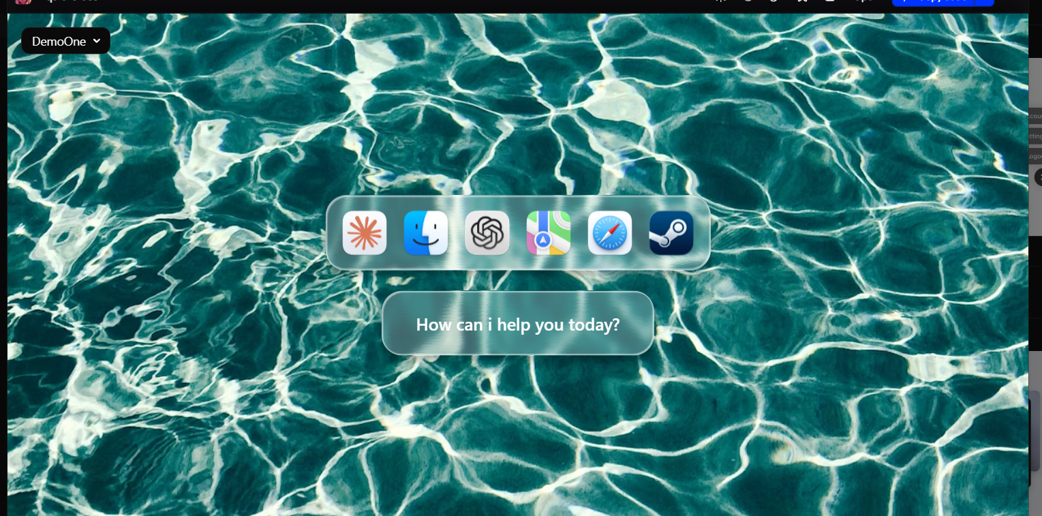
"use client";

import React from "react";

// Types
interface GlassEffectProps {
children: React.ReactNode;
className?: string;
style?: React.CSSProperties;
href?: string;
target?: string;
}

interface DockIcon {
src: string;
alt: string;
onClick?: () => void;
}

// Glass Effect Wrapper Component
const GlassEffect: React.FC<GlassEffectProps> = ({
children,
className = "",
style = {},
href,
target = "_blank",
}) => {
const glassStyle = {
boxShadow: "0 6px 6px rgba(0, 0, 0, 0.2), 0 0 20px rgba(0, 0, 0, 0.1)",
transitionTimingFunction: "cubic-bezier(0.175, 0.885, 0.32, 2.2)",
...style,
};

const content = (
<div
className={`relative flex font-semibold overflow-hidden text-black cursor-pointer transition-all duration-700 ${className}`}
style={glassStyle}
>
{/* Glass Layers */}
<div
className="absolute inset-0 z-0 overflow-hidden rounded-inherit rounded-3xl"
style={{
backdropFilter: "blur(3px)",
filter: "url(#glass-distortion)",
isolation: "isolate",
}}
/>
<div
className="absolute inset-0 z-10 rounded-inherit"
style={{ background: "rgba(255, 255, 255, 0.25)" }}
/>
<div
className="absolute inset-0 z-20 rounded-inherit rounded-3xl overflow-hidden"
style={{
boxShadow:
"inset 2px 2px 1px 0 rgba(255, 255, 255, 0.5), inset -1px -1px 1px 1px rgba(255, 255, 255, 0.5)",
}}
/>

{/* Content */}
<div className="relative z-30">{children}</div>
</div>
);

return href ? (
<a href={href} target={target} rel="noopener noreferrer" className="block">
{content}
</a>
) : (
content
);
};

// Dock Component
const GlassDock: React.FC<{ icons: DockIcon[]; href?: string }> = ({
icons,
href,
}) => (
<GlassEffect
href={href}
className="rounded-3xl p-3 hover:p-4 hover:rounded-4xl"
>
<div className="flex items-center justify-center gap-2 rounded-3xl p-3 py-0 px-0.5 overflow-hidden">
{icons.map((icon, index) => (
<img
key={index}
src={icon.src}
alt={icon.alt}
className="w-16 h-16 transition-all duration-700 hover:scale-110 cursor-pointer"
style={{
transformOrigin: "center center",
transitionTimingFunction: "cubic-bezier(0.175, 0.885, 0.32, 2.2)",
}}
onClick={icon.onClick}
/>
))}
</div>
</GlassEffect>
);

// Button Component
const GlassButton: React.FC<{ children: React.ReactNode; href?: string }> = ({
children,
href,
}) => (
<GlassEffect
href={href}
className="rounded-3xl px-10 py-6 hover:px-11 hover:py-7 hover:rounded-4xl overflow-hidden"
>
<div
className="transition-all duration-700 hover:scale-95"
style={{
transitionTimingFunction: "cubic-bezier(0.175, 0.885, 0.32, 2.2)",
}}
>
{children}
</div>
</GlassEffect>
);

// SVG Filter Component
const GlassFilter: React.FC = () => (
<svg style={{ display: "none" }}>
<filter
id="glass-distortion"
x="0%"
y="0%"
width="100%"
height="100%"
filterUnits="objectBoundingBox"
>
<feTurbulence
type="fractalNoise"
baseFrequency="0.001 0.005"
numOctaves="1"
seed="17"
result="turbulence"
/>
<feComponentTransfer in="turbulence" result="mapped">
<feFuncR type="gamma" amplitude="1" exponent="10" offset="0.5" />
<feFuncG type="gamma" amplitude="0" exponent="1" offset="0" />
<feFuncB type="gamma" amplitude="0" exponent="1" offset="0.5" />
</feComponentTransfer>
<feGaussianBlur in="turbulence" stdDeviation="3" result="softMap" />
<feSpecularLighting
in="softMap"
surfaceScale="5"
specularConstant="1"
specularExponent="100"
lightingColor="white"
result="specLight"
>
<fePointLight x="-200" y="-200" z="300" />
</feSpecularLighting>
<feComposite
in="specLight"
operator="arithmetic"
k1="0"
k2="1"
k3="1"
k4="0"
result="litImage"
/>
<feDisplacementMap
in="SourceGraphic"
in2="softMap"
scale="200"
xChannelSelector="R"
yChannelSelector="G"
/>
</filter>
</svg>
);
// Main Component
export const Component = () => {
const dockIcons: DockIcon[] = [
{
src: "https://parsefiles.back4app.com/JPaQcFfEEQ1ePBxbf6wvzkPMEqKYHhPYv8boI1Rc/a13d1acfd046f503f987c1c95af582c8_low_res_Claude.png",
alt: "Claude",
},
{
src: "https://parsefiles.back4app.com/JPaQcFfEEQ1ePBxbf6wvzkPMEqKYHhPYv8boI1Rc/9e80c50a5802d3b0a7ec66f3fe4ce348_low_res_Finder.png",
alt: "Finder",
},
{
src: "https://parsefiles.back4app.com/JPaQcFfEEQ1ePBxbf6wvzkPMEqKYHhPYv8boI1Rc/c2c4a538c2d42a8dc0927d7d6530d125_low_res_ChatGPT___Liquid_Glass__Default_.png",
alt: "Chatgpt",
},
{
src: "https://parsefiles.back4app.com/JPaQcFfEEQ1ePBxbf6wvzkPMEqKYHhPYv8boI1Rc/6d26d432bd65c522b0708185c0768ec3_low_res_Maps.png",
alt: "Maps",
},
{
src: "https://parsefiles.back4app.com/JPaQcFfEEQ1ePBxbf6wvzkPMEqKYHhPYv8boI1Rc/7c59c945731aecf4f91eb8c2c5f867ce_low_res_Safari.png",
alt: "Safari",
},
{
src: "https://parsefiles.back4app.com/JPaQcFfEEQ1ePBxbf6wvzkPMEqKYHhPYv8boI1Rc/b7f24edc7183f63dbe34c1943bef2967_low_res_Steam___Liquid_Glass__Default_.png",
alt: "Steam",
},
];

return (
<div
className="min-h-screen h-full flex items-center justify-center font-light relative overflow-hidden w-full"
style={{
background: `url("https://images.unsplash.com/photo-1432251407527-504a6b4174a2?q=80&w=1480&auto=format&fit=crop&ixlib=rb-4.1.0&ixid=M3wxMjA3fDB8MHxwaG90by1wYWdlfHx8fGVufDB8fHx8fA%3D%3D") center center`,
animation: "moveBackground 60s linear infinite",
}}
>
<GlassFilter />

<div className="flex flex-col gap-6 items-center justify-center w-full">
<GlassDock icons={dockIcons} href="https://x.com/notsurajgaud" />

<GlassButton href="https://x.com/notsurajgaud">
<div className="text-xl text-white">
<p>How can i help you today?</p>
</div>
</GlassButton>
</div>
</div>
);
}

4.
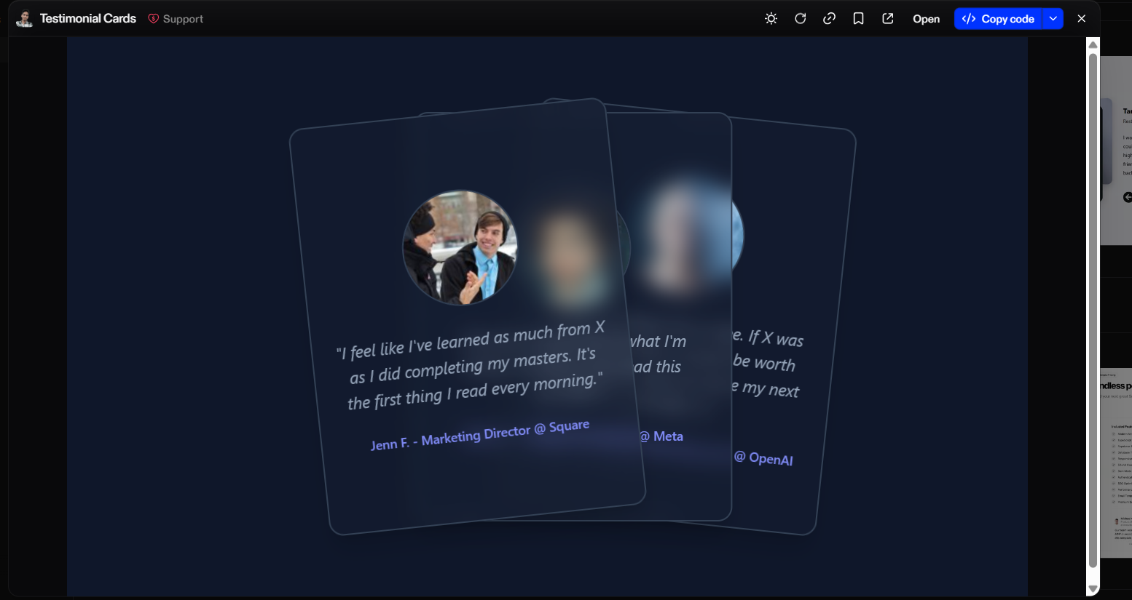
"use client";

import * as React from 'react';
import { motion } from 'framer-motion';

export function TestimonialCard ({ handleShuffle, testimonial, position, id, author }) {
const dragRef = React.useRef(0);
const isFront = position === "front";

return (
<motion.div
style={{
zIndex: position === "front" ? "2" : position === "middle" ? "1" : "0"
}}
animate={{
rotate: position === "front" ? "-6deg" : position === "middle" ? "0deg" : "6deg",
x: position === "front" ? "0%" : position === "middle" ? "33%" : "66%"
}}
drag={true}
dragElastic={0.35}
dragListener={isFront}
dragConstraints={{
top: 0,
left: 0,
right: 0,
bottom: 0
}}
onDragStart={(e) => {
dragRef.current = e.clientX;
}}
onDragEnd={(e) => {
if (dragRef.current - e.clientX > 150) {
handleShuffle();
}
dragRef.current = 0;
}}
transition={{ duration: 0.35 }}
className={`absolute left-0 top-0 grid h-[450px] w-[350px] select-none place-content-center space-y-6 rounded-2xl border-2 border-slate-700 bg-slate-800/20 p-6 shadow-xl backdrop-blur-md ${
isFront ? "cursor-grab active:cursor-grabbing" : ""
}`}
>
<img
src={`https://i.pravatar.cc/128?img=${id}`}
alt={`Avatar of ${author}`}
className="pointer-events-none mx-auto h-32 w-32 rounded-full border-2 border-slate-700 bg-slate-200 object-cover"
/>
<span className="text-center text-lg italic text-slate-400">"{testimonial}"</span>
<span className="text-center text-sm font-medium text-indigo-400">{author}</span>
</motion.div>
);
};

5.
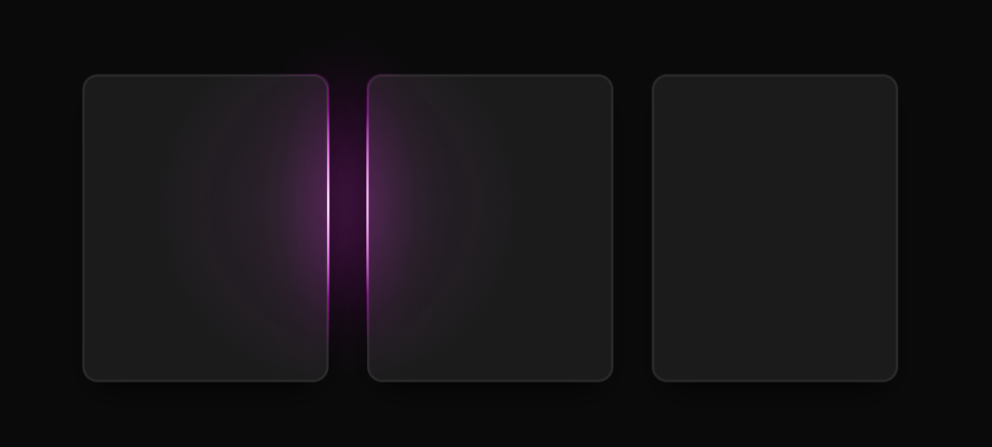
import React, { useEffect, useRef, ReactNode } from 'react';

interface GlowCardProps {
children: ReactNode;
className?: string;
glowColor?: 'blue' | 'purple' | 'green' | 'red' | 'orange';
size?: 'sm' | 'md' | 'lg';
width?: string | number;
height?: string | number;
customSize?: boolean; // When true, ignores size prop and uses width/height or className
}

const glowColorMap = {
blue: { base: 220, spread: 200 },
purple: { base: 280, spread: 300 },
green: { base: 120, spread: 200 },
red: { base: 0, spread: 200 },
orange: { base: 30, spread: 200 }
};

const sizeMap = {
sm: 'w-48 h-64',
md: 'w-64 h-80',
lg: 'w-80 h-96'
};

const GlowCard: React.FC<GlowCardProps> = ({
children,
className = '',
glowColor = 'blue',
size = 'md',
width,
height,
customSize = false
}) => {
const cardRef = useRef<HTMLDivElement>(null);
const innerRef = useRef<HTMLDivElement>(null);

useEffect(() => {
const syncPointer = (e: PointerEvent) => {
const { clientX: x, clientY: y } = e;

if (cardRef.current) {
cardRef.current.style.setProperty('--x', x.toFixed(2));
cardRef.current.style.setProperty('--xp', (x / window.innerWidth).toFixed(2));
cardRef.current.style.setProperty('--y', y.toFixed(2));
cardRef.current.style.setProperty('--yp', (y / window.innerHeight).toFixed(2));
}
};

document.addEventListener('pointermove', syncPointer);
return () => document.removeEventListener('pointermove', syncPointer);
}, []);

const { base, spread } = glowColorMap[glowColor];

// Determine sizing
const getSizeClasses = () => {
if (customSize) {
return ''; // Let className or inline styles handle sizing
}
return sizeMap[size];
};

const getInlineStyles = () => {
const baseStyles = {
'--base': base,
'--spread': spread,
'--radius': '14',
'--border': '3',
'--backdrop': 'hsl(0 0% 60% / 0.12)',
'--backup-border': 'var(--backdrop)',
'--size': '200',
'--outer': '1',
'--border-size': 'calc(var(--border, 2) * 1px)',
'--spotlight-size': 'calc(var(--size, 150) * 1px)',
'--hue': 'calc(var(--base) + (var(--xp, 0) * var(--spread, 0)))',
backgroundImage: `radial-gradient(
var(--spotlight-size) var(--spotlight-size) at
calc(var(--x, 0) * 1px)
calc(var(--y, 0) * 1px),
hsl(var(--hue, 210) calc(var(--saturation, 100) * 1%) calc(var(--lightness, 70) * 1%) / var(--bg-spot-opacity, 0.1)), transparent
)`,
backgroundColor: 'var(--backdrop, transparent)',
backgroundSize: 'calc(100% + (2 * var(--border-size))) calc(100% + (2 * var(--border-size)))',
backgroundPosition: '50% 50%',
backgroundAttachment: 'fixed',
border: 'var(--border-size) solid var(--backup-border)',
position: 'relative' as const,
touchAction: 'none' as const,
};

// Add width and height if provided
if (width !== undefined) {
baseStyles.width = typeof width === 'number' ? `${width}px` : width;
}
if (height !== undefined) {
baseStyles.height = typeof height === 'number' ? `${height}px` : height;
}

return baseStyles;
};

const beforeAfterStyles = `
[data-glow]::before,
[data-glow]::after {
pointer-events: none;
content: "";
position: absolute;
inset: calc(var(--border-size) * -1);
border: var(--border-size) solid transparent;
border-radius: calc(var(--radius) * 1px);
background-attachment: fixed;
background-size: calc(100% + (2 * var(--border-size))) calc(100% + (2 * var(--border-size)));
background-repeat: no-repeat;
background-position: 50% 50%;
mask: linear-gradient(transparent, transparent), linear-gradient(white, white);
mask-clip: padding-box, border-box;
mask-composite: intersect;
}

[data-glow]::before {
background-image: radial-gradient(
calc(var(--spotlight-size) * 0.75) calc(var(--spotlight-size) * 0.75) at
calc(var(--x, 0) * 1px)
calc(var(--y, 0) * 1px),
hsl(var(--hue, 210) calc(var(--saturation, 100) * 1%) calc(var(--lightness, 50) * 1%) / var(--border-spot-opacity, 1)), transparent 100%
);
filter: brightness(2);
}

[data-glow]::after {
background-image: radial-gradient(
calc(var(--spotlight-size) * 0.5) calc(var(--spotlight-size) * 0.5) at
calc(var(--x, 0) * 1px)
calc(var(--y, 0) * 1px),
hsl(0 100% 100% / var(--border-light-opacity, 1)), transparent 100%
);
}

[data-glow] [data-glow] {
position: absolute;
inset: 0;
will-change: filter;
opacity: var(--outer, 1);
border-radius: calc(var(--radius) * 1px);
border-width: calc(var(--border-size) * 20);
filter: blur(calc(var(--border-size) * 10));
background: none;
pointer-events: none;
border: none;
}

[data-glow] > [data-glow]::before {
inset: -10px;
border-width: 10px;
}
`;

return (
<>
<style dangerouslySetInnerHTML={{ __html: beforeAfterStyles }} />
<div
ref={cardRef}
data-glow
style={getInlineStyles()}
className={`
${getSizeClasses()}
${!customSize ? 'aspect-[3/4]' : ''}
rounded-2xl
relative
grid
grid-rows-[1fr_auto]
shadow-[0_1rem_2rem_-1rem_black]
p-4
gap-4
backdrop-blur-[5px]
${className}
`}
>
<div ref={innerRef} data-glow></div>
{children}
</div>
</>
);
};

export { GlowCard }

6.
"use client"

import * as React from "react"
import { cn } from "@/lib/utils";
import { motion } from "motion/react";

export interface ImageGenerationProps {
children: React.ReactNode;
}

export const ImageGeneration = (
({ children} : ImageGenerationProps) => {
const [progress, setProgress] = React.useState(0);
const [loadingState, setLoadingState] = React.useState<
"starting" | "generating" | "completed"
>("starting");
const duration = 30000;

React.useEffect(() => {
const startingTimeout = setTimeout(() => {
setLoadingState("generating");

const startTime = Date.now();

const interval = setInterval(() => {
const elapsedTime = Date.now() - startTime;
const progressPercentage = Math.min(
100,
(elapsedTime / duration) * 100
);

setProgress(progressPercentage);

if (progressPercentage >= 100) {
clearInterval(interval);
setLoadingState("completed");
}
}, 16);

return () => clearInterval(interval);
}, 3000);

return () => clearTimeout(startingTimeout);
}, [duration]);

return (
<div className="flex flex-col gap-2">
<motion.span
className="bg-[linear-gradient(110deg,var(--color-muted-foreground),35%,var(--color-foreground),50%,var(--color-muted-foreground),75%,var(--color-muted-foreground))] bg-[length:200%_100%] bg-clip-text text-transparent text-base font-medium"
initial={{ backgroundPosition: "200% 0" }}
animate={{
backgroundPosition:
loadingState === "completed" ? "0% 0" : "-200% 0",
}}
transition={{
repeat: loadingState === "completed" ? 0 : Infinity,
duration: 3,
ease: "linear",
}}
>
{loadingState === "starting" && "Getting started."}
{loadingState === "generating" && "Creating image. May take a moment."}
{loadingState === "completed" && "Image created."}
</motion.span>
<div className="relative rounded-xl border bg-card max-w-md overflow-hidden">
{children}
<motion.div
className="absolute w-full h-[125%] -top-[25%] pointer-events-none backdrop-blur-3xl"
initial={false}
animate={{
clipPath: `polygon(0 ${progress}%, 100% ${progress}%, 100% 100%, 0 100%)`,
opacity: loadingState === "completed" ? 0 : 1,
}}
style={{
clipPath: `polygon(0 ${progress}%, 100% ${progress}%, 100% 100%, 0 100%)`,
maskImage:
progress === 0
? "linear-gradient(to bottom, black -5%, black 100%)"
: `linear-gradient(to bottom, transparent ${progress - 5}%, transparent ${progress}%, black ${progress + 5}%)`,
WebkitMaskImage:
progress === 0
? "linear-gradient(to bottom, black -5%, black 100%)"
: `linear-gradient(to bottom, transparent ${progress - 5}%, transparent ${progress}%, black ${progress + 5}%)`,
}}
/>
</div>
</div>
);
}
);

ImageGeneration.displayName = "ImageGeneration";

7.
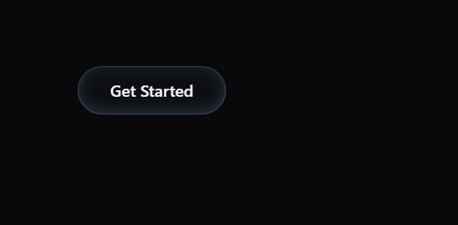
"use client"

import * as React from "react"
import { cn } from "@/lib/utils"

interface HoverButtonProps extends React.ButtonHTMLAttributes<HTMLButtonElement> {
children: React.ReactNode
}

const HoverButton = React.forwardRef<HTMLButtonElement, HoverButtonProps>(
({ className, children, ...props }, ref) => {
const buttonRef = React.useRef<HTMLButtonElement>(null)
const [isListening, setIsListening] = React.useState(false)
const [circles, setCircles] = React.useState<Array<{
id: number
x: number
y: number
color: string
fadeState: "in" | "out" | null
}>>([])
const lastAddedRef = React.useRef(0)

const createCircle = React.useCallback((x: number, y: number) => {
const buttonWidth = buttonRef.current?.offsetWidth || 0
const xPos = x / buttonWidth
const color = `linear-gradient(to right, var(--circle-start) ${xPos * 100}%, var(--circle-end) ${
xPos * 100
}%)`

setCircles((prev) => [
...prev,
{ id: Date.now(), x, y, color, fadeState: null },
])
}, [])

const handlePointerMove = React.useCallback(
(event: React.PointerEvent<HTMLButtonElement>) => {
if (!isListening) return

const currentTime = Date.now()
if (currentTime - lastAddedRef.current > 100) {
lastAddedRef.current = currentTime
const rect = event.currentTarget.getBoundingClientRect()
const x = event.clientX - rect.left
const y = event.clientY - rect.top
createCircle(x, y)
}
},
[isListening, createCircle]
)

const handlePointerEnter = React.useCallback(() => {
setIsListening(true)
}, [])

const handlePointerLeave = React.useCallback(() => {
setIsListening(false)
}, [])

React.useEffect(() => {
circles.forEach((circle) => {
if (!circle.fadeState) {
setTimeout(() => {
setCircles((prev) =>
prev.map((c) =>
c.id === circle.id ? { ...c, fadeState: "in" } : c
)
)
}, 0)

setTimeout(() => {
setCircles((prev) =>
prev.map((c) =>
c.id === circle.id ? { ...c, fadeState: "out" } : c
)
)
}, 1000)

setTimeout(() => {
setCircles((prev) => prev.filter((c) => c.id !== circle.id))
}, 2200)
}
})
}, [circles])

return (
<button
ref={buttonRef}
className={cn(
"relative isolate px-8 py-3 rounded-3xl",
"text-foreground font-medium text-base leading-6",
"backdrop-blur-lg bg-[rgba(43,55,80,0.1)]",
"cursor-pointer overflow-hidden",
"before:content-[''] before:absolute before:inset-0",
"before:rounded-[inherit] before:pointer-events-none",
"before:z-[1]",
"before:shadow-[inset_0_0_0_1px_rgba(170,202,255,0.2),inset_0_0_16px_0_rgba(170,202,255,0.1),inset_0_-3px_12px_0_rgba(170,202,255,0.15),0_1px_3px_0_rgba(0,0,0,0.50),0_4px_12px_0_rgba(0,0,0,0.45)]",
"before:mix-blend-multiply before:transition-transform before:duration-300",
"active:before:scale-[0.975]",
className
)}
onPointerMove={handlePointerMove}
onPointerEnter={handlePointerEnter}
onPointerLeave={handlePointerLeave}
{...props}
style={{
"--circle-start": "var(--tw-gradient-from, #a0d9f8)",
"--circle-end": "var(--tw-gradient-to, #3a5bbf)",
}}
>
{circles.map(({ id, x, y, color, fadeState }) => (
<div
key={id}
className={cn(
"absolute w-3 h-3 -translate-x-1/2 -translate-y-1/2 rounded-full",
"blur-lg pointer-events-none z-[-1] transition-opacity duration-300",
fadeState === "in" && "opacity-75",
fadeState === "out" && "opacity-0 duration-[1.2s]",
!fadeState && "opacity-0"
)}
style={{
left: x,
top: y,
background: color,
}}
/>
))}
{children}
</button>
)
}
)

HoverButton.displayName = "HoverButton"

export { HoverButton }

